📊 Comprehensive Banking Analytics – Power BI Dashboard
🌟 Project Overview
This Power BI Dashboard provides a 360° analytical view of banking operations, covering:
- ✔ Customer Insights
- ✔ Transaction Insights
- ✔ Loan & Branch Analytics
- ✔ Feedback & Service Quality Metrics
It is designed with a modern UI, gradient themes, icons, and interactive filters to make analysis smooth, clear, and enjoyable.
Perfect for data analytics portfolios, business reporting, and advanced Excel/Power BI demonstrations.

🎯 Key Objectives
- 🧮 Analyze deposits, withdrawals, transactions & customer base
- 🏦 Monitor loan applications, approvals & interest rate patterns
- 👥 Understand customer behavior by gender, account type & feedback
- 📍 Explore branch performance across KPIs
- 📊 Build a visually rich & highly interactive BI dashboard

📸 Dashboard Snapshots
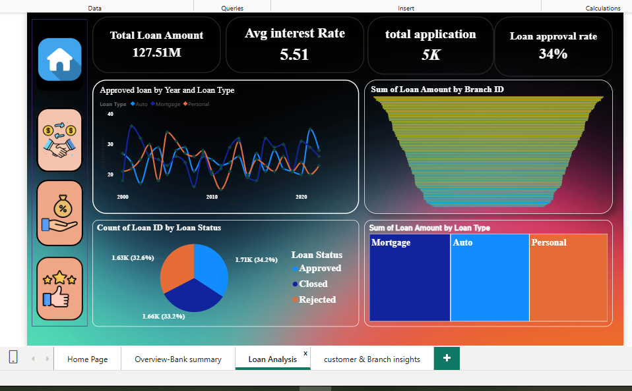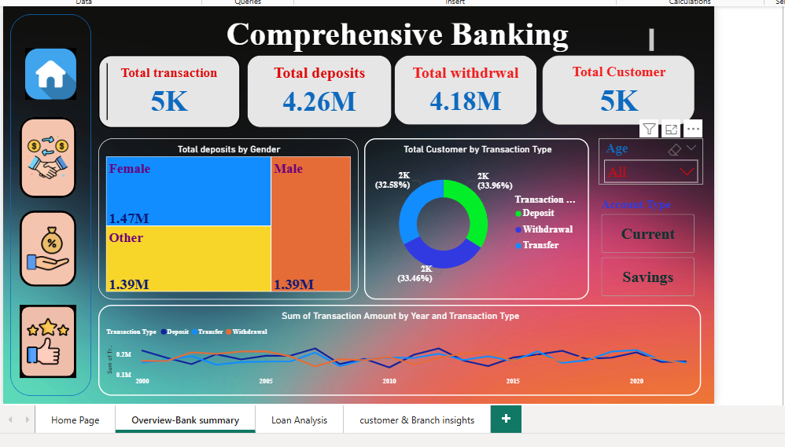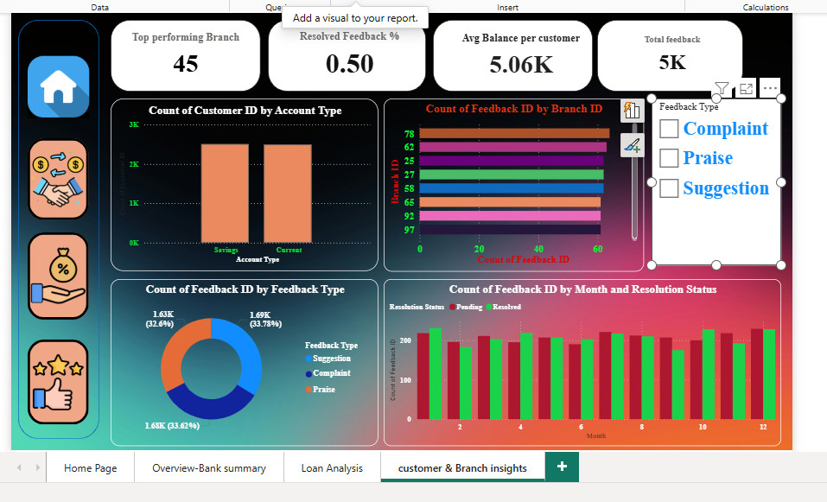
🔵 Bank Summary Dashboard
🔶 Loan Analysis Dashboard
🟢 Customer & Branch Insights Dashboard

🧩 Dashboard Modules
📁 1. Bank Summary Overview
- Total Transactions: 5K
- Total Deposits: 4.26M
- Total Withdrawal: 4.18M
- Total Customers: 5K
- Gender-wise deposit patterns
- Transaction type distribution
- Year-wise transaction trends

🏦 2. Loan Analysis
- Total Loan Amount: 127.51M
- Avg Interest Rate: 5.51%
- Total Applications: 5K
- Loan Approval Rate: 34%
- Loan status distribution (Approved, Rejected, Closed)
- Loan Type Analysis (Mortgage, Auto, Personal)

👥 3. Customer & Branch Insights
- Top Performing Branch
- Avg Balance per Customer
- Total Feedback Overview
- Feedback Type (Complaint, Praise, Suggestion)
- Resolution Status Trends
- Branch-wise Feedback Count
- Customer Count by Account Type

🛠️ Tools Used
- Power BI Desktop
- DAX for KPIs
- Power Query for data transformation
- Interactive slicers & buttons
- Icons and gradient UI theme

🧠 Skills Demonstrated
- Power BI Dashboard Design
- Data Cleaning & Modeling
- DAX Calculations
- KPI Card Creation
- Drill-through & Navigation Pages
- Visual Storytelling & UX Design

📂 Project Files
- Bank_Dashboard.pbix – Power BI dashboard file
- Dataset.xlsx – Source dataset (if included)
- Screenshots (PNG) for GitHub preview

🚀 How to Use
- Download the .pbix file from this repository
- Open in Power BI Desktop (latest version)
- Explore visuals using filters for age, account type & feedback type
- Switch between pages using the left menu icons

🌱 Future Enhancements
- Add drill-through for customer-level analysis
- Integrate real-time data with SQL database
- Add forecasting models for loan approvals and deposits
- Create mobile-friendly Power BI view

✨ About the Creator
👤 Ashwini Mohite (Ashu Jadhav)
📌 Aspiring Data Analyst
💡 Skilled in Excel | SQL | Power BI | Dashboards
🔗 LinkedIn- /in/ashvinijadhav20 / GitHub- /Ashvini-Jadhav

⭐ Support This Project
If you like this dashboard:
🌟 Please give it a star on GitHub — it motivates me to share more projects!

